

**REPUBLIC OF CAMEROON**

**Peace-Work-Fatherland**

**MINISTER OF HIGHER EDUCATION**

**FACULTY OF ENGINEERING**

**AND TECHNOLOGY**

**REPUBLIQUE DU CAMEROON**

**PAIX-Travail-Patrie**

**MINISTRE DE L’ENSEIGNEMENT**

**SUPERIEUR**

**FACULTE D’INGINERIE**

**ET TECHGNOLOGIE**

**FACULTY OF ENGINEERING AND TECHNOLOGY**

**Department : Computer Engineering**

**CEF 440: Internet Programming and Mobile programming**

**TASK 5**

**UI DESIGN AND IMPLEMENTATION**

**GROUP MEMBERS:**

|  |  |
| --- | --- |
| **Names** | **Matriculation** |
| **ALAIN NKEH MBUNKUH** | **FE21A133** |
| **ANANFACK ZANGO ANGELA CARINE** | **FE21A137** |
| **CHO WESLEY MUNGO** | **FE21A160** |
| **NKWETI MANGEM ANCELIA** | **FE21A280** |
| **NTUI RAOUL NTUI RAOUL** | **FE21A288** |

**COURSE INSTRUCTOR : Dr NKEMENI VALERY**

Table of Contents

1. INTRODUCTION_________________________________________________________3

1.1. UI Design Definition_______________________________________________3

1.2. Design Principles__________________________________________________4

2. UI DESIGN PROCESS_____________________________________________________4

2.1. Research and Requirement Gathering__________________________________4

2.2. Low-fidelity Sketches______________________________________________4

2.3. Prototyping_______________________________________________________6

2.4. Key UI Components________________________________________________6

2.4.1. Student interface UI design___________________________________6

2.4.2. Instructor interface UI design________________________________11

2.4.3. Administrator interface UI design_____________________________14

3. UI IMPLEMENTATION__________________________________________________19

3.1. Technology Stack_________________________________________________19

3.2. Development Process______________________________________________19

4. ITERATIVE IMPROVEMENTS____________________________________________19

5. CONCLUSION__________________________________________________________19

1. **INTRODUCTION**

In today’s educational environment, ensuring accurate and efficient attendance tracking is a critical component for both administrative operations and academic integrity. Traditional methods of attendance tracking such as manual roll-calling or paper-based sign-in sheets are prone to errors, inefficiencies, and potential manipulation. To address these issues, a Biometric Student Attendance System offers a robust solution by leveraging biometric technology to automate and secure the process of student attendance recording.

To address these issues and usher in a new era of efficient attendance tracking, this report presents the UI design and implementation of a biometric student attendance mobile application. The primary objective of this system is to enhance the reliability and efficiency of attendance tracking through the use of biometric authentication methods such as fingerprint. By implementing such a system, educational institutions can achieve a higher level of accuracy in attendance records, reduce administrative burdens, and enhance overall security.

* 1. **UI Design Definition**

User interface (UI) design is the process designers use to build interfaces in software or computerized devices, focusing on looks or style. Designers aim to create interfaces which users find easy to use and pleasurable. UI design refers to graphical user interfaces and other forms—e.g., voice-controlled interfaces, graphic user interface.

To design UIs best, you should consider:

1. **Users judge designs quickly and care about**[**usability**](https://www.interaction-design.org/literature/topics/usability)**and likeability**

* They don’t care about your design, but about getting their tasks done easily and with minimum effort.
* Your design should therefore be “invisible”: Users shouldn’t focus on it but on completing tasks: e.g., ordering pizza on Domino’s Zero Click app.
* So, understand your users’ contexts and task flows (which you can find from, e.g., [customer journey maps](https://www.interaction-design.org/literature/topics/customer-journey-maps)), to fine-tune the best, most intuitive UIs that deliver seamless experiences.

1. **UIs should also be enjoyable (or at least satisfying and frustration-free).**

* When your design predicts users’ needs, they can enjoy more personalized and immersive experiences. Delight them, and they’ll keep returning.
* Where appropriate, elements of [gamification](https://www.interaction-design.org/literature/topics/gamification) can make your design more fun.

1. **UIs should communicate brand values and reinforce users’ trust.**

* Good design is [emotional design](https://www.interaction-design.org/literature/topics/emotional-design). Users’ associate good feelings with brands that speak to them at all levels and keep the magic of pleasurable, seamless experiences alive.
  1. **Designs Principles**

The UI design of the mobile application is guided by the following essential principles:

* Simplicity and Clarity: The interface should be clean, minimalist, and easy to navigate. This is achieved by removing unnecessary elements and visual elements throughout the app, and implementing intuitive navigation patterns.
* Responsiveness: The UI should adapt seamlessly to different screen sizes and orientations. This is achieved by employing responsive design techniques such as adaptive layouts and flexible grids.
* Feedback and Response: The UI should provide visual feedback and loading indicators to reassure users that their actions to reassure users that their actions have been registered in other word provide immediate feedback for user actions. . This is achieved by incorporating micro interactions like animations, color changes, or haptic feedback.
* Aesthetics: Creating visually appealing designs that enhance user satisfaction and engagement.
* Consistency: Providing a uniform look and feel across the application to enhance familiarity and ease of use.

1. **UI Design Process**

To create a successful biometric student attendance mobile app, we followed a design process that involved research, wireframing, and prototyping.

* 1. **Research and Requirement Gathering**
* **User Personas:** We began by researching out to our target audience that’s our primary users and their specific needs.
* **Stakeholder interviews:** We conducted interviews with our key stakeholders that is students, lecturers and administrators to understand their pain points and their expectation in this biometric student attendance app.
* **Competitive Analysis**: We also conducted competitive research to see what other biometric student attendance apps were available in the market and what features they offered.
  1. **Low- Fidelity Sketches**

After conducting research, we created low –fidelity sketch to map out the user flow and the app’s layout. The low-fidelity sketch allowed us to visualize the app’s structure and ensure that the user flow was intuitive.

* Key screens designed include:
* **Login screens:** Login screen for both student and instructor for user authentication.
* **Registration screen:** Mark the beginning of the student on-boarding process and sets the tone for the overall user experience.
* **Home Screen:** Home screen designed to be a dashboard that provide quick access to the most important features of the system.
* **Attendance Making Screen:** Interface for recording attendance.
* **Fingerprint Enrollment Screen:** Interface to enroll student fingerprint.
* **Attendance reports Screen:** Viewing and exporting attendance reports.

Low fidelity sketch of the student interface we did

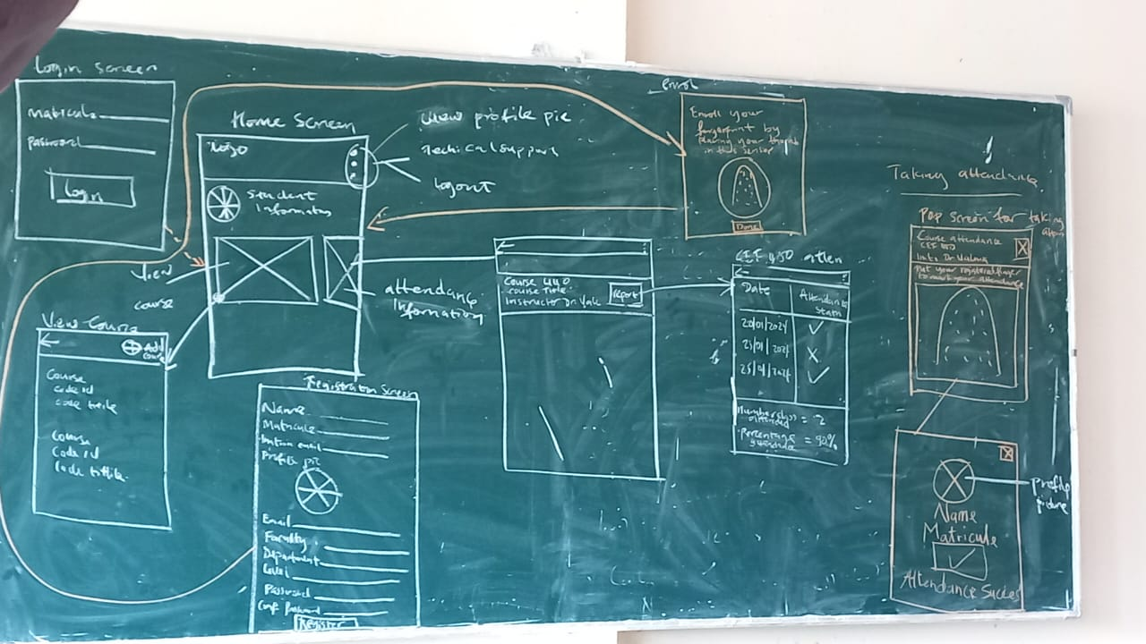Figure 1: student interface low-fidelity prototype

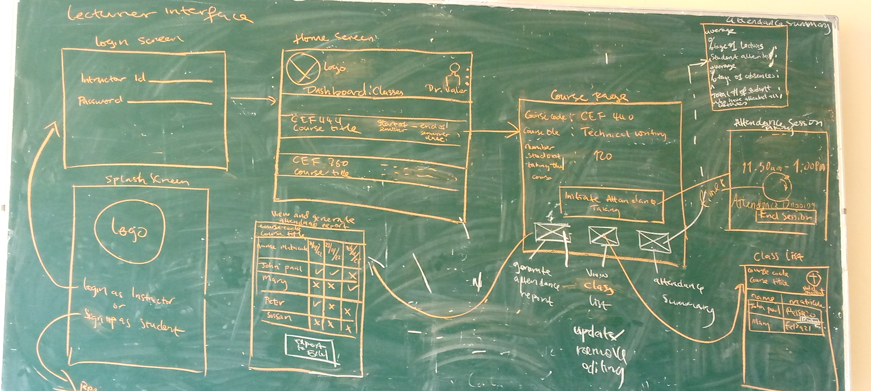Figure 2: lecturer interface low-fidelity prototype

* 1. **Prototyping**

With the wireframes finalized, we developed high-fidelity interactive prototypes using Figma, a collaborative design tool. The prototype allowed us to text the user flow and user interface design. This is the prototype link: [*CLICK HERE*](https://www.figma.com/proto/YeWyqCWOxffFtCRGqK9FAo/Untitled?node-id=0-1&t=zEduMFf6bYTH979j-1)

* 1. **Key UI components**
     1. **Student Interface UI Design**
* Splash , Role Screen and Student login page

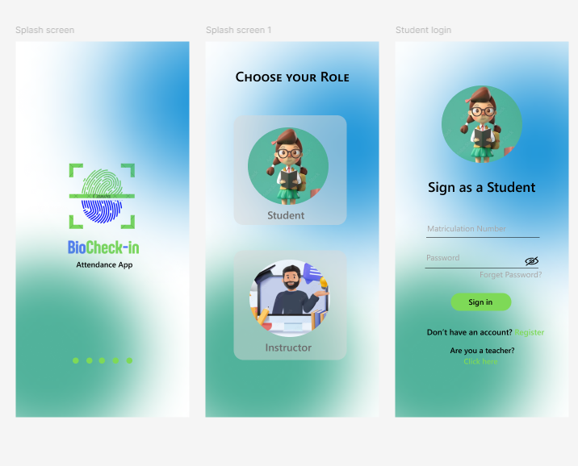

* Registration Screen, Fingerprint Enrollment Screen and Home Screen

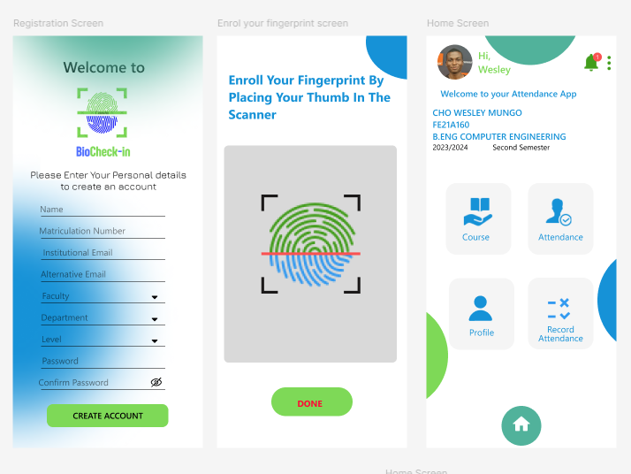

* 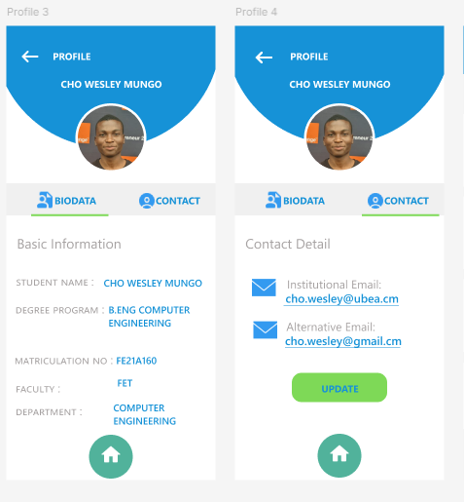Profile Screens
* Course and Add Screen

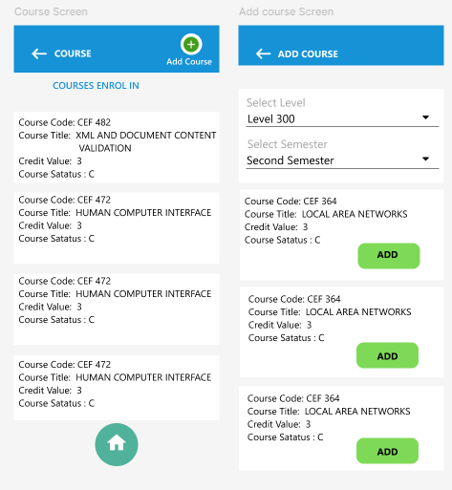

* Attendance and Attendance info Screen

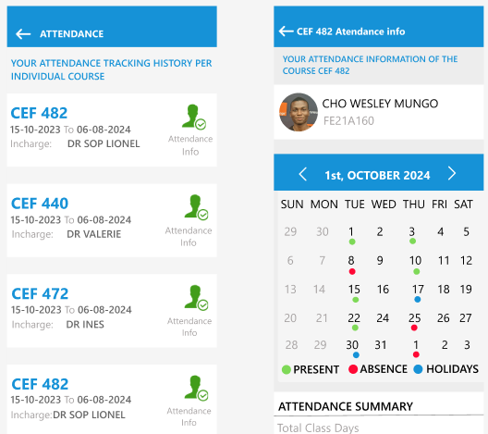

* Record Attendance Screens

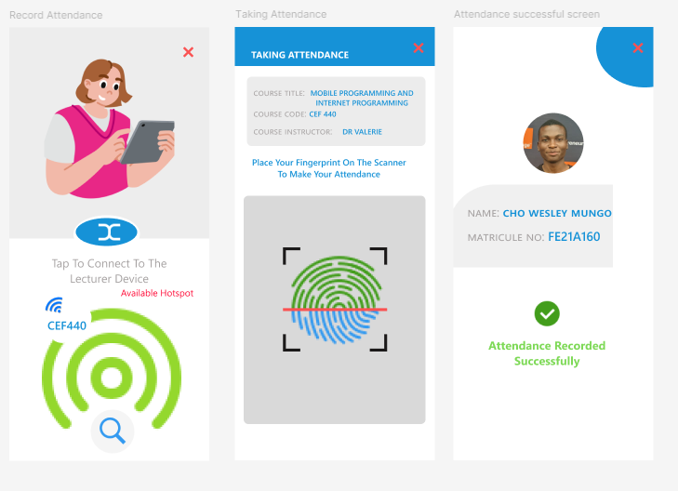

* + 1. **Instructor Interface UI design**
* Instructor login, Instructor Dashboard and Course Screen

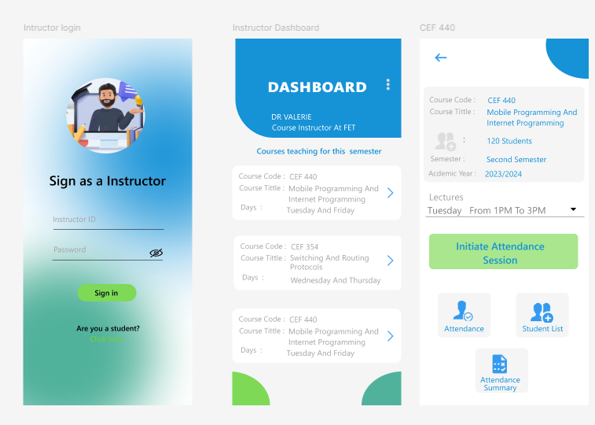

* Course Screen and Attendance Screen

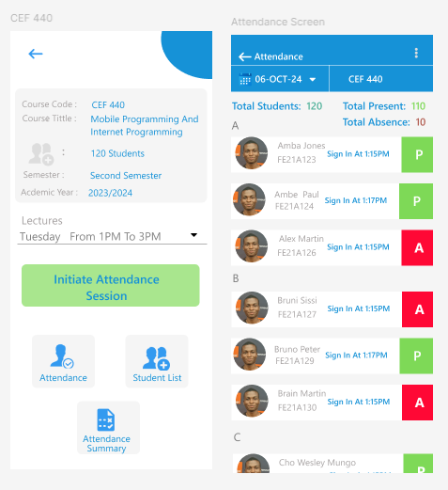

* Student list and Add New Student Screen

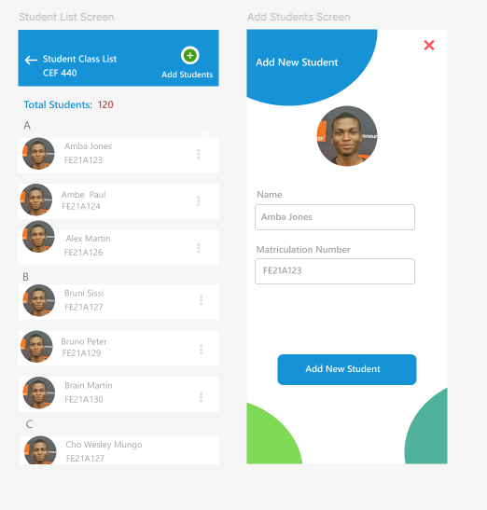

* Pop up Screen and View Student Personalize Attendance information

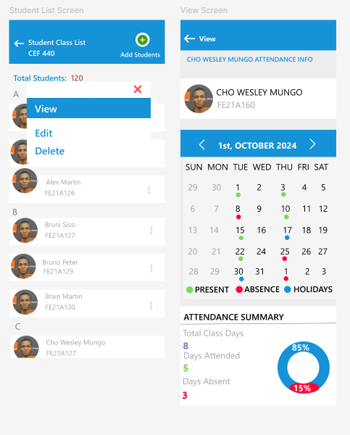

* Course Screen And Attendance Summary Screen

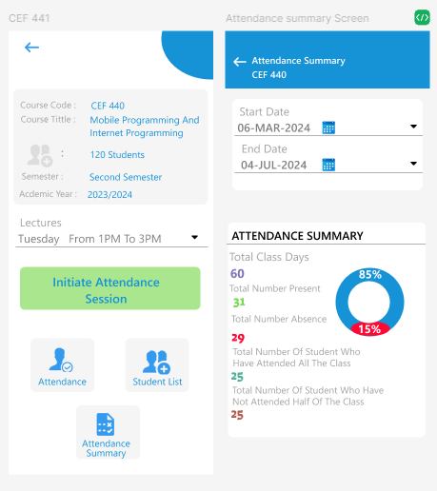

* Course Screen and Attendance Session Screen

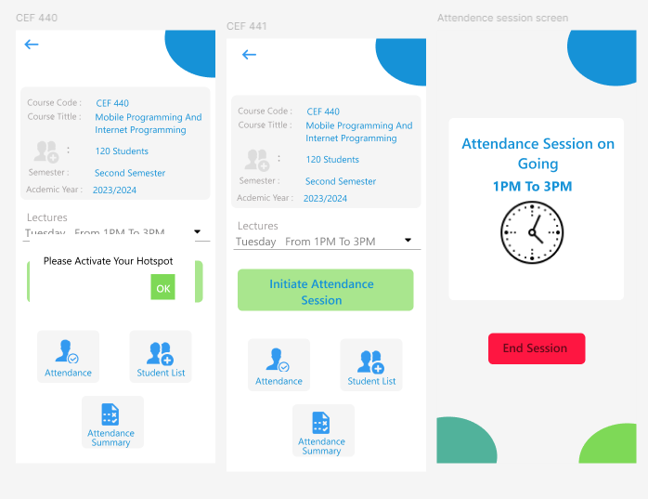

* + 1. **Administrator UI design Interface**
* Administrators Dashboard

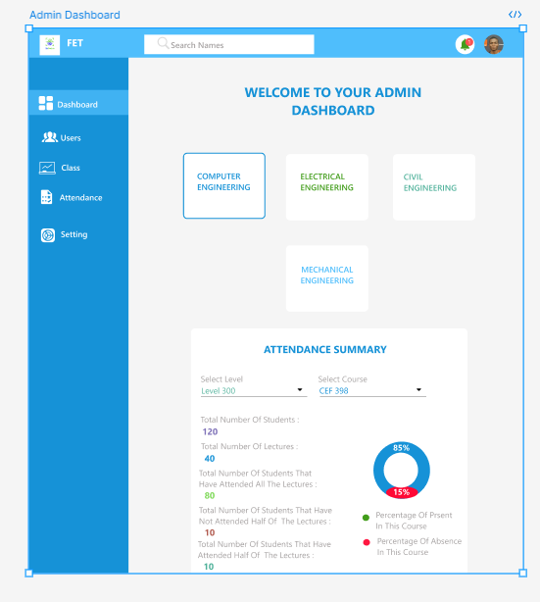

* User Management Screen (Student)

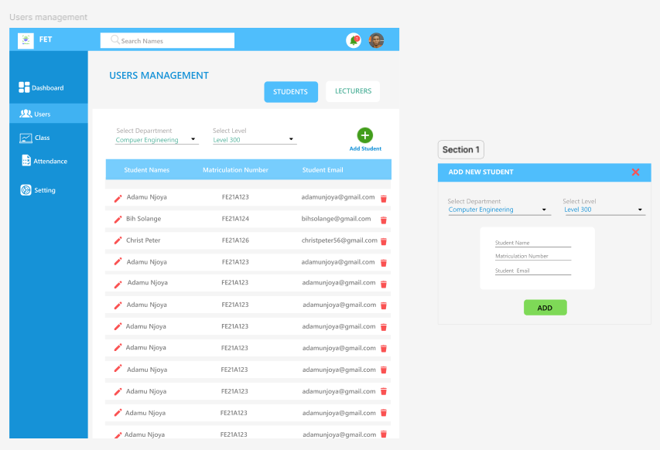

* User Management Screen ( For Lecturers)

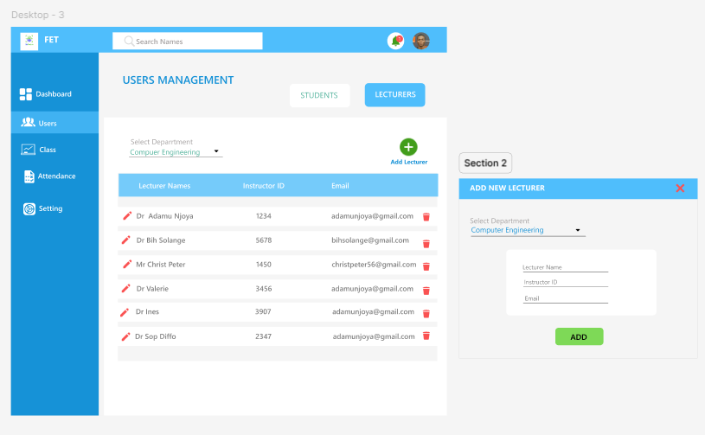

* Class Management Screen

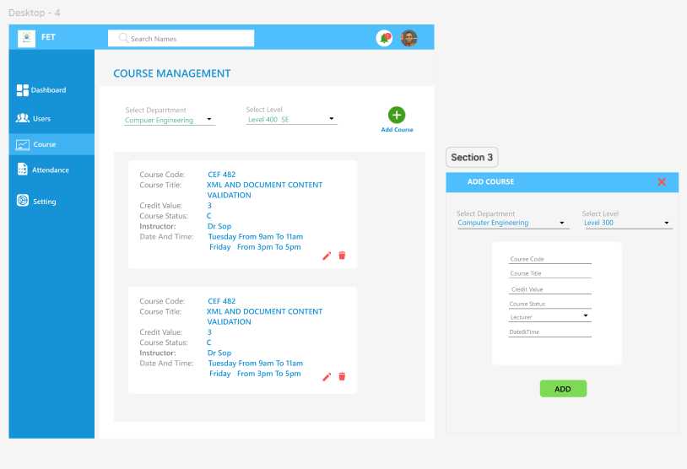

* Student Attendance Screen

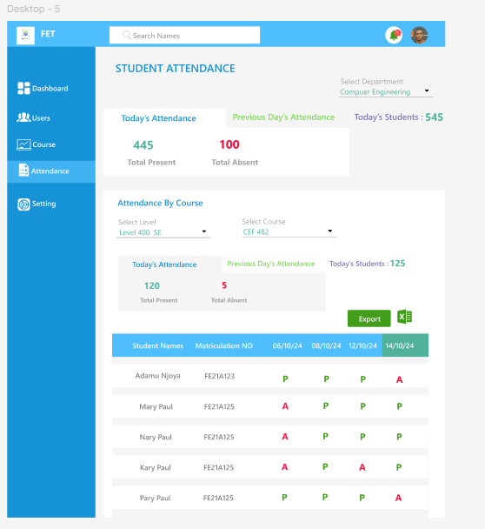

1. **UI Implementation**
   1. **Technology Stack**

* **Frontend Development:** Flutter both for Android and IOS.
* **Design Tools:** Figma for design and prototyping
* **Logo Design Tools:** We used Canva for our logo designing
* **For the Admin Panel/ Dashboard** we are going to Reactjs to code the UI interface
  1. **Development Process**
* **Component-Based Architecture:** Designs reusable UI components for consistency and efficiency.
* **Response Design:** Ensure the app adapts to various screen sizes and orientations.

1. **Iterative Improvements**

* **Usability Enhancements**: Made improvements based on user feedback to enhance usability.

1. **Conclusion**

The UI design and implementation of the biometric attendance mobile application focused on creating a user-friendly, secure, and efficient interface. By adhering to design principles, incorporating user feedback and ensuring accessibility, we have developed and application that meets the needs of students, lecturers, and administrators.